One-Sample t-Test – Example 1 (Stats Ability) Answer Key

Does the statistics ability of KSU graduates differ from the national average? The average on the national statistics exam is μ = 5.8.

Step 1. State your hypotheses.
a. Is it a one-tailed or two-tailed test? two-tailed test

b. Hypotheses in words
H_{A}: The statistics ability of KSU graduates differs from the national average.

H₀: The statistical ability of KSU graduates does not differ from (is the same as) the national average.

c. Statistical hypotheses
H_{A}: μ_{KSU} ≠ 5.8

H₀: μ_{KSU} = 5.8

Step 2. Set the significance level ➔ α = .05 Determine t_{crit}. t_{crit} = + 2.262

Step 3. Select and compute the appropriate statistical test.

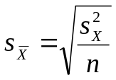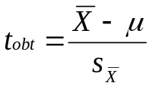
KSU  stats score  (X) |  | X – | (X –)²
10 | 9.9 | .1 | .01
15 | 9.9 | 5.1 | 26.01
13 | 9.9 | 3.1 | 9.61
5 | 9.9 | -4.9 | 24.01
8 | 9.9 | -1.9 | 3.61
7 | 9.9 | -2.9 | 8.41
9 | 9.9 | -.9 | .81
9 | 9.9 | -.9 | .81
10 | 9.9 | .1 | .01
13 | 9.9 | 3.1 | 9.61
ΣX = 99 |  |  | ∑(X –)²  = 82.9
= 9.9
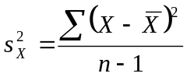

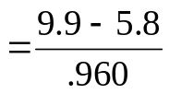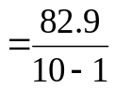
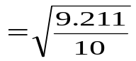

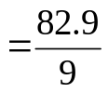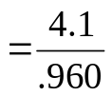
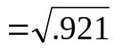

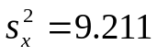
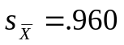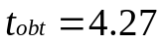

Step 4. Make a decision. Determine whether the value of the test statistic is in the critical region. Draw a picture. Label t_{crit} and t_{obt}.
Is z_{obt} in the critical region? Yes
Should you reject or retain the H₀? Reject

t_{obt} = 4.27

t_{crit} = -2.262 t_{crit} = +2.262

Step 5. Report the statistical results.

t(9) = 4.27, p < .05

Step 6. Write a conclusion.

The statistical ability of KSU graduates (M = 9.9) is higher than the national average (µ = 5.8).

Step 7. Compute the estimated d.

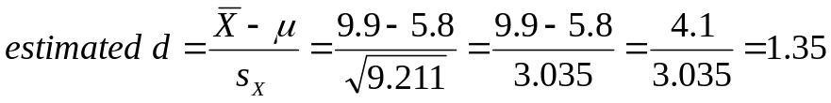

Step 8. Compute r² and write a conclusion.

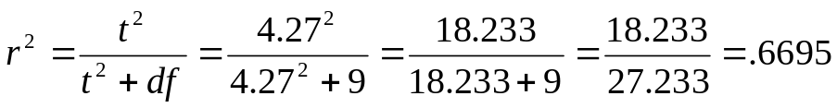

Approximately 66.95% of the variance in statistics ability is attributable to (or can be accounted for by) the fact that the sample consists of KSU graduates.

or

The fact that the sample consists of KSU graduates accounts for 66.95% of the variance in statistics ability.

